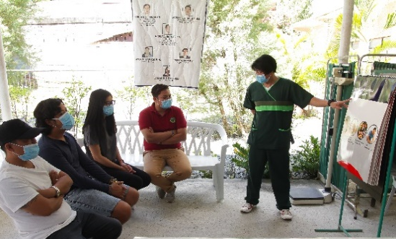
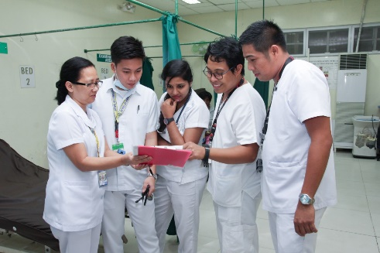

Background
2 in every 10 married Filipinas wishing to postpone their next birth or stop childbearing are not using a family planning method—is linked to limited access to quality family planning service. (NDHS 2017)
Aligning Workforce Competencies with Health Sector Needs: Clinical Competency Assessment Package
Technical Advisory
Human resources for health form the foundation of an efficient and resilient health system. In the Philippines, significant variations in quality of healthcare service is attributed to uneven capacity of local government units to manage both the delivery of quality primary care services, which includes Family Planning & Maternal Child Health (FP/MCH) and Tuberculosis (TB) services, and the local health workforce. This fragmented distribution of a confident, fit-for-work and fit-for-practice workforce across the country directly impacts equitable distribution of quality health services among Filipino communities and the Philippines ability to fulfill national and global commitments to improve key health outcomes.
Guaranteed universal access to family planning information in all public health facilities outlined in the Responsible Planning and Reproductive Health Law. (RA 10354)
Among women aged 15-49 who are not using contraception, only 14 per cent of them who visited a health facility discussed family planning with a health provider. (NDHS 2017)
The passing of Republic 11223 or Universal Health Act provides an opportunity for strengthening the delivery primary care services to the underserved and marginalized. The UHC ensures a “whole-of-society approach to health…centered on the needs and preferences of individuals, families and communities [while] address[in] the broader determinants”. It also outlines improvements for health human resources management through the formulation and implementation of a National Health Human Resource Masterplan that will “provide policies and strategies for the appropriate generation, recruitment, retraining, regulation, retention and reassessment of health workforce based on population needs.” Such strategies include the development of clinical competencies and competency assessment measures for primary care services (including TB and FP/MCH).
The gap between the estimated number of TB cases and those found and notified to the National Tuberculosis Program indicate poor adherence of health providers to national TB guidelines. (NTPS 2016)
Results from series of focus group discussion among health workers in TB exemplar sites in 2018 report that health workers were not confident in fulfilling their job functions because they did not receive ample preparation during pre-service education. (HRH2030 2018)
The periodic and regular review of health worker knowledge, skills and attitudes in providing TB and FP/MCH clinical services is critical in aligning health workforce competencies with health sector needs. More importantly, routine competency assessments ensure a FP/MCH and TB practice-ready and work-ready primary care workforce is developed and maintained.
Due to this clear need, USAID’s HRH2030/Philippines developed a Competency Assessment Package that builds on the current policy environment and past investments. Overall the Competency Assessment Package supports and aligns with strategic objectives and provisions outlined in the: National Tuberculosis Program’s Manual of Operations (2015); Responsible Parenthood and Reproductive Health Act RPRH Law RA 10354: RA11148 or Kalusugan at Nutrisyon ng Mag-Nanay Act, and primary health care approach and competencies espoused by the UHC Act. The package also reflects and builds on DOH’s Competency Catalog and clinical competencies outlined in their Midwife and Nurse Certification Program. It can also serve as an example for developing and evaluating other primary care clinical competencies to be developed by the Philippines Department of Health (DOH) and other stakeholders in the future.
Objectives
The objectives of the competency assessment are both micro and macro in nature to support with planning and management of the health workforce improve health outcomes:
- Informs training needs of individual health workers and subsequently can support the planning of trainings for a region. If health workers are consistently scoring less than 50% on a competency area, decision makers in the region may consider planning a training for their region on the competency area. In addition, the competency assessment can guide coaching and mentoring by supervisors. Finally, health workers can use the competency assessment tool as a guide to understand the clinical areas that they should feel confident in practicing as these align with best practices, approved procedures, and overall health priorities.
- Allows managers and decision makers to understand the competency level of the workforce to provide quality health services. At a more macro level, the results of the competency assessment can be used to better understand where there are overall gaps in health workforce ability to respond to population health needs. For example, if competency assessment results are demonstrating trends in weaknesses of certain competency areas, then perhaps the training is falling short, the clinical procedure needs to be examined more closely and/or the health workforce make up for the competency area needs to be examined based on the results of the competency assessment.
Population Health Needs
Current demand on the health sector
Health Workforce
Competency level of the health workforce to respond to these needs
Planning and Management
To enable a fit for practice, ready for work health workforce

Tools
The following tools were developed to assist in the implementation of the competency assessment.
Tool | Target Audience | Brief Description | Tool
Family Planning and Tuberculosis Competency Dictionary and Assessment Tool | All users of the competency assessment tool, including DOH, PHO, CHDs, and RHUs | Competency dictionary for FP and TB competencies, including indicators for knowledge, skills and attitudes.
Competency Assessment Standard Operating Procedure | All users of the competency assessment tool, including DOH, PHO, CHDs, and RHUs | Standards operating procedure for implementation of the assessment tool.
Competency Review Report | DOH, PHO and CHDs as a key reference | Literature review and focus group discussions to inform the development of the competency dictionary and assessment tool.
Process Map: Competency Assessment, eLearning, PTE | DOH, PHO and CHDs as a key reference | To guide those using the competency assessment and eLearning developed by USAID’s HRH2030 Project, funded by USAID, and those implementing post-training evaluation to better understand how these three key components to health workforce development can build on each other and interact.

Roles and Responsibilities
There are different perspectives and stakeholders that should be engaged in a competency assessment. These include Provincial Health Officers (PHOs), Regional Health Office Center for Health Development (CHD), supervisors of the health worker, representatives from the personnel unit of the health facility and the health workers themselves. Overall, the competency-based health worker assessments should be conducted by the PHO or CHD, though the tool can be used by supervisors of health workers to provide coaching and mentoring. In addition, the tool can be used by the health workers themselves during their own voluntary self-review or in preparation for the PHO led assessment.
PHO & CHD | RHU Supervisors | RHU Personnel Unit | Health Worker
- Determines the objectives of the assessment  - Overseas all planning and preparations  - Engages local stakeholders as appropriate  - Conducts assessment  - Reviews results with health worker  - Uses results to inform planning and decision making, including coaching of RHU supervisors on use of the tool for coaching | - Coordinates with PHO/CHD in organization of the assessment and providing feedback on how to use results  - Uses the assessment tool, and results of the assessment to inform coaching and mentoring for the health workers | - Provides data as requested on the make up of the health workforce at a facility, including job position, descriptions and other information to better contextualize the results of the assessment | - Uses the Self-Assessment Checklist as a tool to support quality improvement  - Participates in the observation assessment conducted by the PHO and/or CHD  - Participate in post-assessment conference to determine action plans for quality improvement

Process
Based on a review of best practices and various processes utilized in the Philippines, the below demonstrates the proposed process that should be utilized when implementing the assessment. The process should be tested after initial piloting and thus revised:

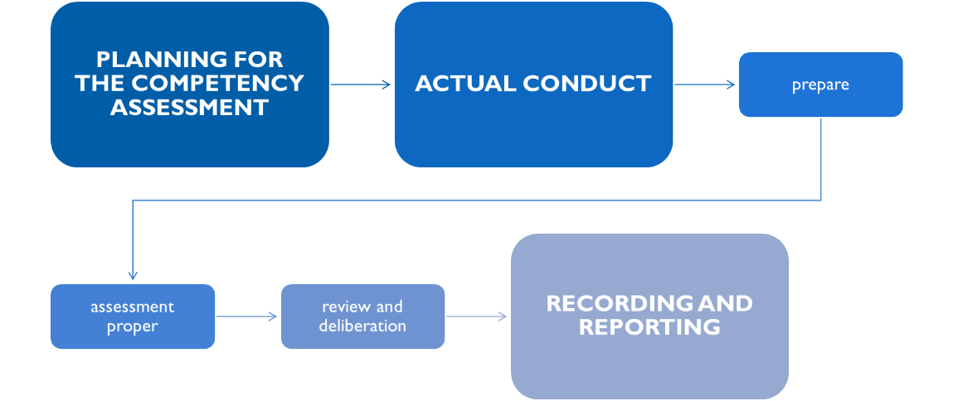

Recommended Next Steps

While the Competency Assessment Tool and Package was developed by USAID’s HRH2030, there is a need for field testing and validation of the tool, which will inform improvements to the dictionary and tool. In the development of the dictionary and tool, the National TB Control Program, Family Planning Program, USAID’s implementing partners (TB Innovations, TB Platforms and ReachHealth), as well as a Regional Health Offices, were consulted. Overall it was recognized that NTP and FPP would determine strategic ways to integrate the tools into planning and management of interventions. In addition, it was clearly indicated that USAID implementing partners, could integrate the competency assessment into future capacity development work planning, and thus testing and validation of the approach could occur to enhance the process.
Overall, there is an enabling environment and ecosystem for the implementation of a competency-based assessment to inform both training needs of the health workforce and understand better gaps in workforce development that could be addressed by evidence informed strategic interventions.

27 February 2019, WHO Fact Sheet Primary Health Care, retrieved from < https://www.who.int/news-room/fact-sheets/detail/primary-health-care>

